**Partner information on Ash Dieback campaign**

We are launching a campaign over the summer to raise awareness about the problem of Ash Dieback disease in Lancashire and to inform tree owners of their responsibilities to check and maintain their trees to ensure they are safe.

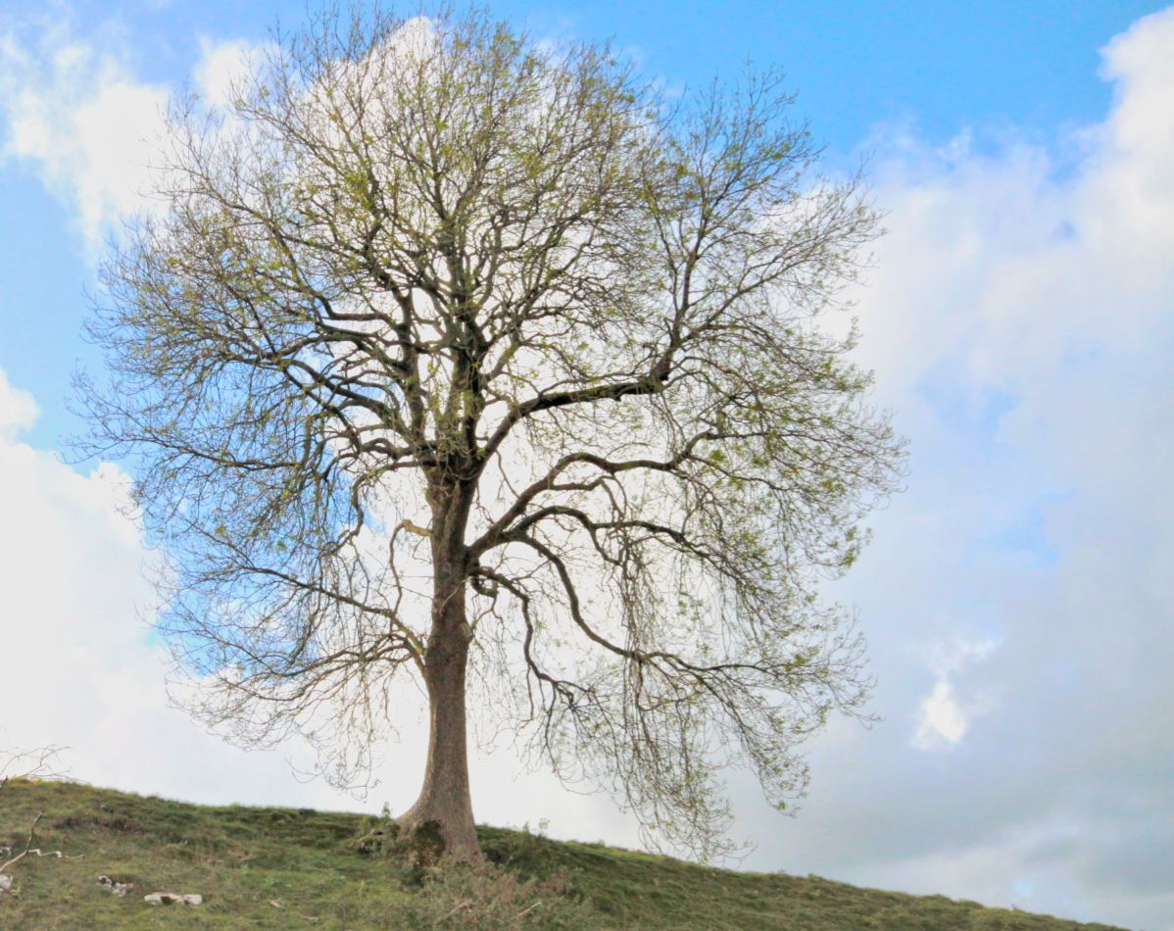

Please help us to promote the campaign in your constituency and encourage people to check their trees and find out more on our web page [www.lancashire.gov.uk/ashdieback](http://www.lancashire.gov.uk/ashdieback)

You can also direct people who want to report a dangerous tree near a highway or footpath to the Report It tool on our website [www.lancashire.gov.uk/roads-parking-and-travel/report-it/](http://www.lancashire.gov.uk/roads-parking-and-travel/report-it/)

**Suggested newsletter article**

Check your trees for Ash Dieback disease

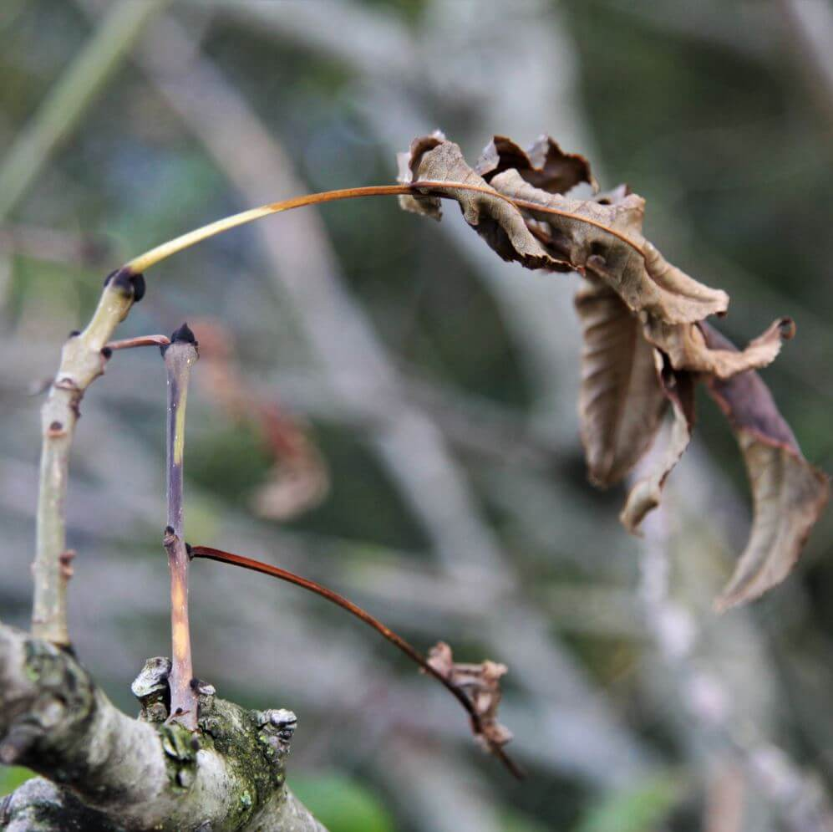

Lancashire County Council is urging anyone with an ash tree on their property to check its health this this summer to ensure it does not become a danger to themselves or others.

Ash Dieback is a highly destructive disease caused by a fungus which has spread throughout the UK in recent years. It can lead to infected trees shedding branches or limbs, or potentially collapsing as the tree dies.

The county council estimates that around 127,000 ash trees next to roads throughout Lancashire will need to be regularly checked to ensure they do not pose a threat to safety.

As some of these trees are on private land, the council has launched a campaign to raise awareness of the issue among residents, businesses and landowners to inform them of their responsibility to make sure their trees near roads and pavements are safe.

There is no cure for the disease and it is fatal in the vast majority of cases. Contamination is beyond the point where the spread of infection can be stopped and the disease is now known to be present across 56% of the UK, including 96% of Lancashire.

The county council will be contacting tree owners over the coming months if their tree is a danger to the highway, but if you have an ash tree which could be a hazard to people or property, you should get it checked out by a qualified arborist. Now that trees are in leaf is the best time to look for signs of the disease in your ash tree/s. It's important to use a properly trained and insured person to carry out work as infected trees can be particularly dangerous.

The council's website has more information on identifying ash trees and signs of the disease, permits and licences you may need, and finding a professional to undertake any work.

Visit Lancashire.gov.uk/ashdieback

**Social media schedule**

Please support our digital campaign by sharing and commenting on our social media posts:

* cid:image001.png@01D213ED.12BFC3E0 [Follow us on Twitter @lancashirecc](http://www.twitter.com/lancashirecc) and re-tweet from your Twitter account.
* [Like us on Facebook](http://www.facebook.com/lancashirecc) from your Facebook profile and share our posts.



Below are some examples of posts -

|  |  |  |
| --- | --- | --- |
| **Date and time** | **Post** | **Channel** |
| 18 June | The summer is an ideal time to check ash trees for signs of #AshDieback, a highly destructive disease affecting ash trees which can make them unstable and dangerous. Watch our new video to find out more about ash dieback and what you need to do as a tree owner. <https://youtu.be/kmtZv5hOfnY> | **Facebook and Twitter** |
| 23 June | Do you own an ash tree? It's your responsibility to make sure your trees are safe as many trees are infected by #AshDieback which can make them dangerous, particularly if they are close to roads, footpaths or property.    More info about identifying an ash tree at [www.lancashire.gov.uk/ashdieback](http://www.lancashire.gov.uk/ashdieback) | **Facebook and Twitter** |